**Examining the Triangular Participation of Teachers, Parents, and Students in** **the Provision of Quality Education in Gamnangtar**

Giriraj Dahal1*, Ramesh Prasad Bhatt2*, Matrika Prakash Dangi3, Prof. Dr. Keshab Prasad Adhikari4

1) Graodaya Yugakabi Siddhicharan Campus, Okhaldhunga

2) Graodaya Yugakabi Siddhicharan Campus, Okhaldhunga

3) Graodaya Yugakabi Siddhicharan Campus, Okhaldhunga

4) Central Department of Population Studies, Tribhuvan Unviersity, Kirtipur, Kathmandu

* Corresponding author email: [dahal2272@gmail.com](mailto:dahal2272@gmail.com), [bhattramesh632@gmail.com](mailto:bhattramesh632@gmail.com)

# **ABSTRACT**

This study explores the foundational "collaboration triangle" of teachers, parents, and students within Gramodaya Yugakabi Siddhicharan Secondary School, a rural educational institution in Okhaldhunga district, Nepal. Recognizing quality education as vital for individual and community progress, particularly in socio-economically challenged regions, this article examines the interconnected roles of these three key stakeholders. The teacher's pedagogical expertise, parental foundational support, and the student's active engagement are posited as crucial elements for fostering a thriving learning environment. By analyzing the synergy and potential challenges within this triad, this research aims to contribute to a deeper understanding of the dynamics that influence student achievement, emotional well-being, and the overall resilience of the educational community in this specific context. Furthermore, preliminary data regarding teachers' subject relevancy is presented, highlighting the alignment between academic qualifications and teaching assignments within the school.

**Keywords**: Collaboration Triangle, Teacher-Parent-Student Relationship, Rural Education, Educational Effectiveness, Nepal, Subject Relevancy

# **INTRODUCTION**

Quality education is widely recognized as a cornerstone for individual and community development, especially in regions striving to overcome socio-economic challenges. In Gamnangtar, a rural area situated along the Likhu River in Okhaldhunga district, Nepal, the pursuit of accessible and effective education is both a community aspiration and a practical necessity. The region’s educational institutions, such as Gramodaya Yugakabi Siddhicharan Secondary School, play a pivotal role in providing learning opportunities to students from diverse backgrounds, including those from economically disadvantaged families and marginalized groups.

At the heart of educational effectiveness lies a dynamic triangular relationship among teachers, parents, and students. This triad, often conceptualized as a “collaboration triangle,” is fundamental to fostering an environment where students can thrive academically, socially, and emotionally. Teachers contribute pedagogical expertise and create engaging learning experiences; parents offer foundational support, reinforce values, and ensure a stable home environment; and students themselves are active agents in their own learning, responsible for engagement and personal growth. When all three parties work in concert, the resulting synergy has been shown to enhance student achievement, promote emotional well-being, and build a resilient educational community. Conversely, if any link in this triangle weakens, the overall quality of education and student outcomes can be significantly compromised.

The context of Gamnangtar, with its ongoing efforts to expand educational infrastructure and increase access, underscores the importance of examining how teachers, parents, and students collaborate to provide quality education. Understanding the patterns, strengths, and challenges of this triangular participation is essential for informing policies and practices that can further elevate educational standards in the region. This research seeks to explore the dynamics of teacher-parent-student collaboration in Gamnangtar, aiming to identify effective strategies and potential areas for improvement in the provision of quality education.

# **METHODOLOGY**

Using a quantitative descriptive-correlational research methodology, the study employs surveys, interviews, and observations to gain nuanced insights into the delivery and impact of tripartite involvement on students' academic performance. In controlled settings where the researcher has command over variables and research objectives, quantitative research is employed to establish connections between variables and results. Focusing on a sample of 20 parents and students of each Grade 8, 9 and 10 students, along with 20 teachers and in Gamnangtar during the academic year 2078/2079, the research aims to offer empirical evidence on the influence of triangular participation on students' academic performance.

This study will employ a mixed-methods research design. Surveys will be distributed to teachers, parents, and students to gather quantitative data on their perceptions and experiences. In-depth interviews with key stakeholders and classroom observations will provide qualitative insights. The combination of these methods will offer a comprehensive understanding of triangular participation in the rural community school setting.

# **DATA ANALYSIS**

1. **Learning difficulties of different subjects**

The results show that a majority of students, specifically 32 out of 60, feel that Nepali is the easiest subject for them. This accounts for more than half of the total respondents. Technical subjects are the next most favored, with 12 students indicating they find these subjects easy. Social Science is considered easy by 7 students, while 5 students feel Health is the easiest subject. English is regarded as easy by only 3 students, and Mathematics is found easy by just 1 student. These findings suggest that while most students are comfortable with Nepali and technical subjects, a significant number struggle with English and Mathematics. The data highlights the need for the school to provide additional support in subjects like Mathematics and English, where students seem to face more challenges.

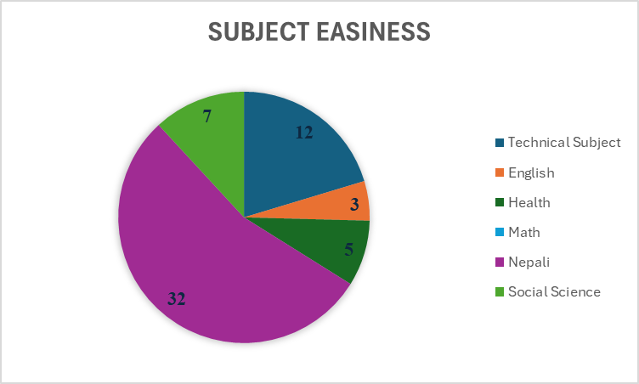

**Figure 1: Students perception on easiness of subject**

Based on the data collected from 60 secondary level students at Gramodaya Yugakabi Siddhicharan Secondary School, a significant number of students experience difficulty in mathematics and science subjects. Specifically, 37 students reported that they find mathematics difficult, making it the subject with the highest level of perceived difficulty among the respondents. In comparison, 22 students indicated that they struggle with science, while only 1 student reported difficulty in optional mathematics. This pattern reflects broader trends observed in various studies, where mathematics is frequently identified as a challenging subject for secondary students, often due to factors such as complex content, teaching methods, and student attitudes toward the subject (Pokhrel, 2023).

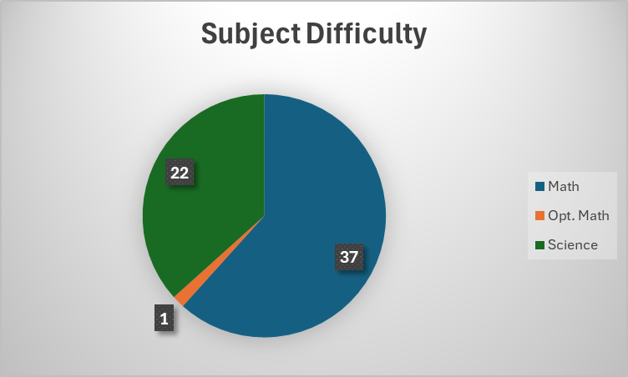

**Figure 2: Students perception on difficulty of subject**

**B) Students’ engagement Pattern**

The result indicates that homework is the most time-consuming activity, prioritized by 26 students (43.3%), followed by unspecified activities categorized as "Others" (20 students, 33.3%). Mobile-related activities, such as gaming or browsing, account for 6 students (10%), while chores occupy 8 students (13.3%). Social media usage is prevalent across all activities, with 16 students (26.7%) reporting they are "always" online, particularly those engaged in homework (10 students) and mobile activities (4 students). Another 8 students (13.3%) use social media "frequently," including those balancing chores (4 students) and homework (2 students). A majority of students (58.3%) access social media "occasionally," primarily during unspecified activities (19 students) or homework (14 students). Only 1 student reported no social media use at all. The data suggests that while homework dominates students' schedules, many engage in concurrent social media use, potentially affecting focus. Mobile activities show high social media engagement, with frequent or constant usage reported by 6 students.

**Table 1: Relation between time allocation across activities and social media usage patterns**

|  |  |  |  |  |  |
| --- | --- | --- | --- | --- | --- |
| **Time Spends mostly on** | **Social Media Use** | | | | **Total** |
| Always | Frequently | Occasionally | Not at all |
| Mobile | 4 | 2 | 0 | 0 | 6 |
| Homework | 10 | 2 | **14** | 0 | 26 |
| Chores | 2 | 4 | 2 | 0 | 8 |
| Others | 0 | 0 | **19** | 1 | 20 |
| Total | 16 | 8 | 35 | 1 | 60 |

**C) Teachers’ degree and teaching subject relevancy**

The analysis of subject relevancy among 25 teachers, as illustrated in the provided bar graph, reveals that a significant majority-17 out of 25 teachers-hold degrees that are directly relevant to the subjects they teach. This accounts for 68% of the total sample, highlighting a strong alignment between teachers' academic backgrounds and their teaching assignments. In contrast, 4 teachers each (16% respectively) possess degrees that are only partially relevant or not relevant at all to their teaching subjects. The visual representation clearly emphasizes the predominance of teachers with relevant qualifications, while also drawing attention to the smaller, yet notable, groups whose qualifications may not fully match their teaching responsibilities. This insight suggests that while most teachers are well-matched to their subjects, there is room for improvement in ensuring all educators have the most appropriate academic backgrounds for their roles.

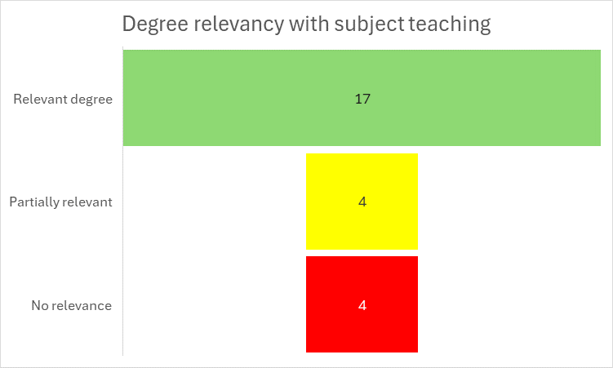

**Figure 3: Teachers subject relevancy with their teaching subject**

# **CONCLUSION**

This study provides valuable insights into the dynamics of the teacher-parent-student collaboration triangle and key factors influencing student learning at Gramodaya Yugakabi Siddhicharan Secondary School. The findings highlight that while Nepali is considered the easiest subject by a majority of students, Mathematics and English pose significant challenges. Additionally, a notable portion of students allocate significant time to homework, often combined with social media use, which may affect their focus. The analysis of teachers' qualifications reveals that most teachers possess degrees relevant to their teaching subjects, but a subset have degrees with partial or no relevance. This article offers a nuanced understanding of the educational dynamics within a rural Nepalese school, pinpointing both strengths and areas requiring attention to enhance the learning experience and student outcomes.

**REFERENCES**

Epstein, J. L. (2001). School, family, and community partnerships: Preparing educators and improving schools. Westview Press.

Pokhrel, M. (2023). Exploring challenges towards learning mathematics among secondary school students in Nepal. Academic Journal of Mathematics Education, 6(1), 20-32.